

TRIBHUVAN UNIVERSITY

INSTITUTE OF SCIENCE AND TECHNOLOGY



HIMALAYA COLLEGE OF ENGINEERING

CHYASAL, LALITPUR

LAB REPORT NO. 11

**SUBMITTED BY: SUBMITTED TO:**

NAME: ABIN TIMILSINA DEPARTMENT OF Bsc. CSIT

ROLL NO.: 04 CHECKED BY:

**Theory**

*Structure:*

Structure is a user defined data types that enables program to strore or collect heterogenous information.

Syntax:

struct<structure_name>  
 {  
 Data_type property1;  
 Data_type property2;  
 ……………………………….  
 Data_type property n;

};

*Declaring structure variable*

1. By struct keyword within main function  
   Eg: int main()

{

Struct student s, s1, s2;

}

1. By declaring variable at the time of structure definition

Eg: struct employee  
 {

Int eid;

Char name[20];

}s1,s2;

*Accessing Member of Structure*

1. By (.) dot operator(mentor operator)
2. By (->) arrow operator(structure pointer operator)

**Question 1**

**WAP to create union employee which has id, name and address as member variable and display employee details.**

*Program:*

#include<stdio.h>

union employee

{

int id;

char name[20];

char add[20];

};

int main()

{

union employee s;

printf("Enter id of employee \n");

scanf("%d",&s.id);

printf("roll=%d \n",s.id);

printf("Enter name of employee \n");

scanf("%s",s.name);

printf("name=%s \n",s.name);

printf("Enter address of employee \n");

scanf("%s",s.add);

printf("Address=%s \n",s.add);

return 0;

}

*Output:*

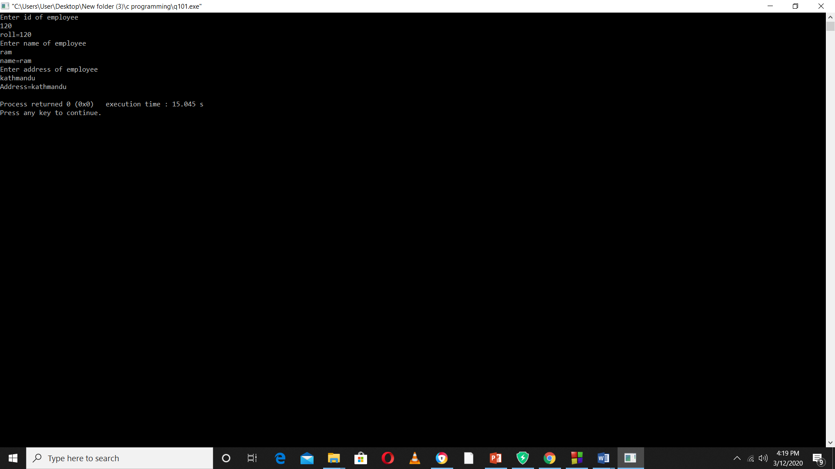

**Question 2**

**WAP to create a structure named company with name, address, phone and number of employee. Read the following and display the member values.**

*Program:*

#include<stdio.h>

struct company

{

char name[20];

char add[20];

int ph;

int no;

};

int main()

{

struct company s;

printf("Input name of company \n");

scanf("%s",s.name);

printf("Input address of company \n");

scanf("%s",s.add);

printf("Input phone no of company \n");

scanf("%d",&s.ph);

printf("Input no of employee of company \n");

scanf("%d",&s.no);

printf("Name=%s \t",s.name);

printf("address=%s \t",s.add);

printf("Phone no=%d \t",s.ph);

printf("No of employee=%d \t",s.no);

return 0;

}

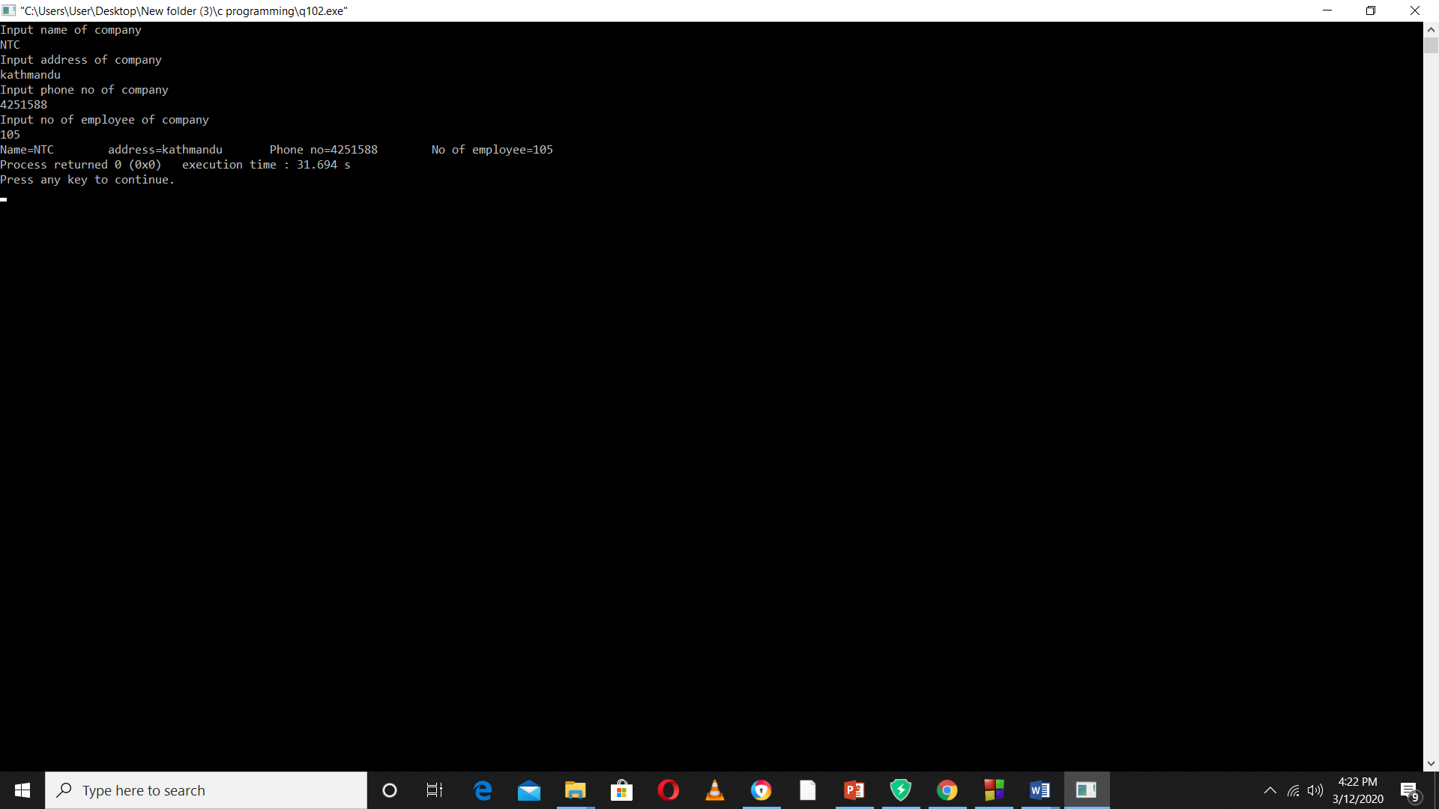

*Output:*

**Question 3**

**WAP to define a structure complex to read the complex number and perform addition in real and imaginary part.**

*Program:*

#include<stdio.h>

struct complex

{

int real;

int img;

};

int main ()

{

struct complex c1,c2,c3,c4;

printf("Enter the real part of 1st complex number");

scanf("%d",&c1.real);

printf("Enter the img part of 1st complex number");

scanf("%d",&c1.img);

printf("Enter the real part of 2nd complex number");

scanf("%d",&c2.real);

printf("Enter the img part of 2nd complex number");

scanf("%d",&c2.img);

c3.real=c1.real+c2.real;

c3.img=c1.img+c2.img;

c4.real=c1.real-c2.real;

c4.img=c1.img-c2.img;

printf("Sum =%d +%d i \n",c3.real,c3.img);

printf("difference= %d-%di \n",c4.real,c4.img);

return 0;

}

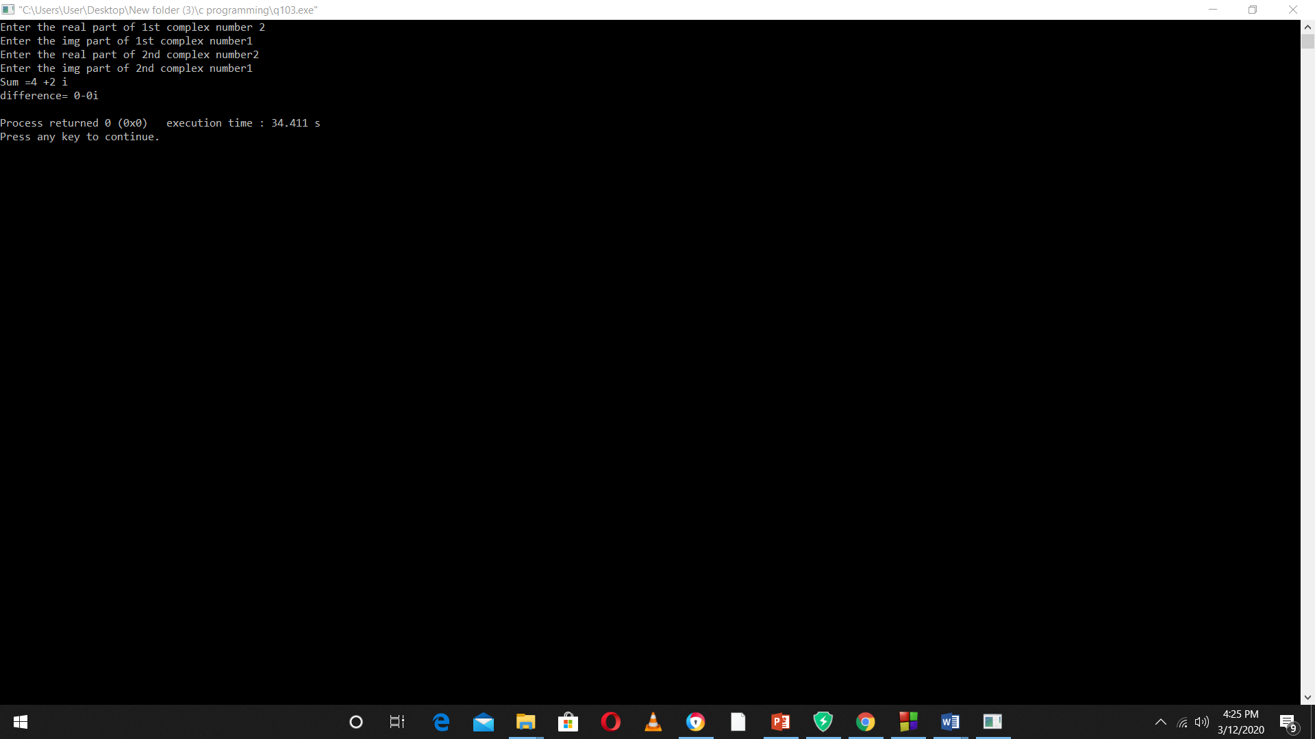

*Output:*

Question 4

**WAP to create a structure named student which has roll no, name, address and average marks of the student as member variables. Read the student information of 12 students.**

*Program:*

#include<stdio.h>

struct student

{

int roll;

char name[20];

char add[20];

float avg;

};

void display (struct student [],int);

int main()

{

struct student c1[12];

int i;

for (i=0;i<12;i++)

{

printf("Enter student info %d \n",i+1);

scanf("%d %s %s %f",&c1[i].roll,c1[i].name,c1[i].add,&c1[i].avg);

}

display (c1,12);

return 0;

}

void display (struct student c1[], int n)

{

int j;

for (j=0;j<n;j++)

{

printf("Student info for %d \n",j+1);

printf("Roll=%d \n Name=%s \n Address=%s\n Average marks=%f \n",c1[j].roll,c1[j].name,c1[j].add, c1[j].avg);

}

return 0;

}

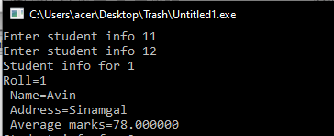*Output:*

**Question 5**

**WAP to add distances in feet and inches using function.**

*Program:*

#include<stdio.h>

struct distance

{

int feet;

int inch;

};

struct distance add(struct distance,struct distance);

int main()

{

struct distance c1,c2,c3;

printf("Enter the feet of 1st distance \n");

scanf("%d",&c1.feet);

printf("Enter the inch of 1st distance \n");

scanf("%d",&c1.inch);

printf("Enter the feet of 2nd distance \n");

scanf("%d",&c2.feet);

printf("Enter the inch of 2nd distance \n");

scanf("%d",&c2.inch);

c3=add(c1,c2);

printf("The distance in feet =%d ' inch=%d ''",c3.feet,c3.inch);

}

struct distance add (struct distance c1,struct distance c2)

{

struct distance z;

z.feet=c1.feet+c2.feet;

z.inch=c1.inch+c2.inch;

if(z.inch>=12)

{

z.feet=(z.feet)+1;

z.inch=(z.inch)-12;

}

return z;

}

*Output:*

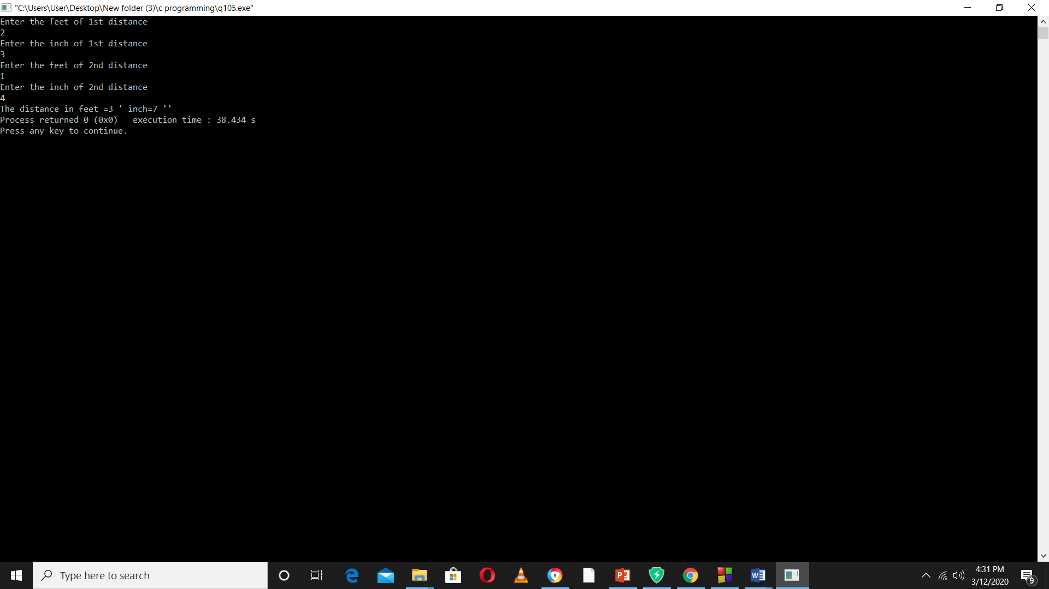

**Conclusion:**

From this we can conclude or we learnt about **structure** and how it is used in array, function, string , structure which makes us easy for programming and we also learned about dot operator and arrow operator which is used in pointer.